7th Annual

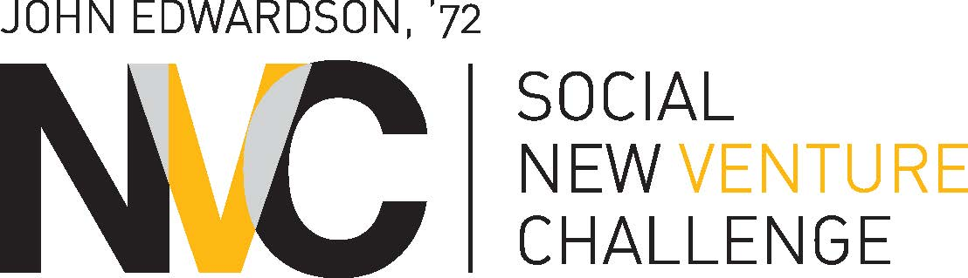

2016-2017
OFFICIAL ENTRY FORM

Phase I Deadline:
Thursday, February 2, 2017, 10 a.m. (CST), via online submission
Entry Checklist - Review before submitting your entry!

- You have written a Business Plan Feasibility Summary that is no more than eight (8) pages (typed and double-spaced only), not including resumes.

- You have provided a copy of the “Cover Sheet” contained in this document with your entry.

- You have read, signed, and attached the “Certifications and Agreements” document contained in this document. This document may be signed electronically and should be included in your entry packet.

- You must submit one electronic copy of entry materials in the following manner for SNVC submission:

- Social New Venture Challenge: Email an electronic copy to: nvc@ChicagoBooth.edu. The electronic copy must have one PDF file attached that includes—in this order--your Cover Sheet, electronically signed Certifications & Agreements, Resumes of Team Members, and the Feasibility Summary. These documents should be combined into one single PDF under with the file named teamname_fs.pdf (for example, [ballotready_fs.pdf]). If you are unsure of how to do combine PDFs, please view: http://www.wikihow.com/Combine-PDF-Files-Using-Adobe-Acrobat.
The email must include the following in the subject line: [team name]: [Social NVC] Feasibility Summary. For example the email would look like this:

To: nvc@ChicagoBooth.edu
Subject: BallotReady: Social NVC Feasibility Summary
File Attached: ballotready_fs.pdf

If you are experiencing problems emailing your feasibility summary due to a large file size, you can use the Chicago Booth file-sharing service. Go to http://share.chicagobooth.edu and follow the instructions.

- Electronic copies must be emailed to the proper email address by 10 a.m. (CST) on Thursday, February 2, 2017. Registration will close precisely at this time, no exceptions.

- Technical questions regarding submission should be sent to Will Gossin at will.gossin@chicagobooth.edu.

- Eligibility questions about the SNVC should be sent to Will Gossin at will.gossin@chicagobooth.edu.

2017 FEASIBILITY SUMMARY COVER SHEET

COMPANY/TEAM NAME:
Team Members (Please list main contact for your team first):

Name | Email Address | Booth Class Year or E/W | Affiliation (if non-Booth)

Please list all the participants who contributed significantly to the Business Idea. Attach additional sheets if necessary.
Business Description (50 words or less, please note that this info may be made available on the SNVC website):

Problem This Business is Addressing:

How Will your Organization Impact Communities:

Initial Target Customer Segment:

Potential Market Size: (if available)

Competing or substitutable products/services: (if available)

Why is this the right team to launch this business?

Key Milestones Achieved or Estimated Time to Market: (if available)

Certifications and Agreements

7th Annual John Edwardson, ’72, Social New Venture Challenge

The University of Chicago Booth School of Business
Social Enterprise Initiative
5807 South Woodlawn Avenue, Chicago, IL 60637

By submitting a Business Idea (“the Idea”) to the University of Chicago Booth School of Business - Social New Venture Challenge (“the Competition”), each Contestant listed below agrees to the following conditions:

Originality of Plan. The ideas and concepts set forth in the Idea are the original work of the Contestants and that the Contestant is not under any agreement or restrictions which prohibit or restrict his or her ability to disclose or submit such ideas or concepts to the Competition.

Compliance with Guidelines of the Competition. Each Contestant has reviewed the Entry Guidelines ("the Competition Guidelines") and by his or her signature below certifies that this entry and the team or individual it represents complies with the Guidelines and agrees to abide by the Guidelines.

Recognition of Prize Money. As a condition to receive the Prize Money, each winning team (that has for-profit status) must agree to provide Chicago Booth with equity in the Company (that was the subject of its business plan) in an amount equal to its respective award if the company receives additional funding or otherwise enters into a business combination transaction wherein the surviving entity receives financing or equity in another entity, within three years of the agreement date.

Waivers and Releases. Each Contestant understands that the University of Chicago Booth School of Business, each of the co-sponsors, judges, mentors, co-organizers (the “Competition Officials”) and its directors, officers, partners, employees, consultants and agents (collectively “Organizer Representatives”) are volunteers and are under no obligation to render any advice or service to any Contestant. The views expressed by the judges, co-sponsors, co-organizers, and the Organizer Representatives are their own and not those of the University of Chicago Booth School of Business or any person or entity.

Each Contestant also understands and agrees that although the Competition Officials have taken and will take the steps described in the Guidelines regarding confidentiality of the ideas and plans submitted by the Contestants, the legal protection of the ideas and plans submitted by the Contestants to the Competition is otherwise the sole responsibility of the Contestant. In consideration of the time, expertise and other resources provided by the Competition Officials and Organizer Representatives to the Competition, each Contestant hereby voluntarily releases each Competition Official and each Organizing Team Member from any further liabilities, responsibilities, and accountabilities relating to or arising out of such Competition Officials or Organizer Representative's participation in the Competition.

Company/Team Name:

Contestants (Team Members): List principal contestant (point-of-contact) first

Name(s): | Signature(s) (Check Box to sign electronically): | Date(s):

