6th Annual
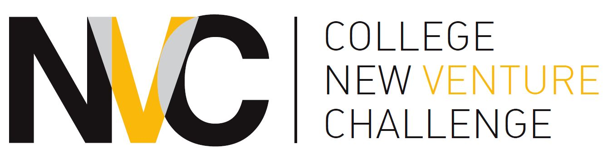

Startup Launch Program
2017-2018

OFFICIAL ENTRY FORMS

Phase I Deadline:
Monday, November 27, 2017, 10:00 a.m. (CST)
College New Venture Challenge Entry Checklist
Use before submitting your entry!

- You have written a Business Plan Feasibility Summary that is no more than eight (8) pages (typed and double-spaced only), not including resumes. Examples of feasibility summaries are available at bit.ly/CNVCresources.

- You have provided a copy of the “Cover Sheet” with your entry.

- You have read, signed, and attached the “Certifications and Agreements” document contained in this document. This document may be signed electronically and should be included in your entry packet.

- You must submit one electronic copy of entry materials in the following manner for submission:

- You must email in your electronic copy to: lucas.peralta@chicagobooth.edu. The electronic copy must have one PDF file attached that includes your Cover Sheet, electronically signed Certifications & Agreements, Resumes of Team Members, and the Feasibility Summary in this order. These documents should be combined into one single PDF. If you are unsure of how to do this, please view: http://www.wikihow.com/Combine-PDF-Files-Using-Adobe-Acrobat
- The email must have the following in the subject line: [team name]: Feasibility Summary. For example the email would look like this:

To: lucas.peralta@chicagobooth.edu
Subject: Freenters: Feasibility Summary

Electronic copies must be emailed to the proper email address by 10:00 a.m. (CST) on November 27, 2017. Registration will close precisely at this time.
2017-18 FEASIBILITY SUMMARY COVER SHEET

COMPANY/TEAM NAME:
Team Members: (Please list main contact for your team first)
Name | Email | Graduation Year | Affiliation  (if non-College) | CNET | Will this person enroll in the winter class?

Please list all the participants who contributed significantly to the Business Idea. Attach additional sheets if necessary.

Business Description: (50 words or less, please note that this info may be made available on the CNVC website)

Problem This Business is Addressing:

Social Impact of Business: (optional)

Customer Segment This Business Addresses:

Potential Market Size: (if available)

Competing or substitutable products: (if available)

Key milestones or estimated time to market: (if available)

Certifications and Agreements

6th Annual College New Venture Challenge

The University of Chicago
Career Advancement & the Polsky Center for Entrepreneurship and Innovation, 5807 South Woodlawn Avenue, Chicago, IL 60637

By submitting a Business Idea (“the Idea”) to the College New Venture Challenge (“the Competition”), each Contestant listed below agrees to the following conditions:

Originality of Plan. The ideas and concepts set forth in the Idea are the original work of the Contestants and that the Contestant is not under any agreement or restrictions which prohibit or restrict his or her ability to disclose or submit such ideas or concepts to the Competition.

Compliance with Guidelines of the Competition. Each Contestant has reviewed the Entry Guidelines ("the Competition Guidelines") and by his or her signature below certifies that this entry and the team or individual it represents complies with the Guidelines and agrees to abide by the Guidelines.

Waivers and Releases. Each Contestant understands that the University of Chicago, each of the co-sponsors, judges, mentors, co-organizers (the “Competition Officials”) and its directors, officers, partners, employees, consultants and agents (collectively “Organizer Representatives”) are volunteers and are under no obligation to render any advice or service to any Contestant. The views expressed by the judges, co-sponsors, co-organizers, and the Organizer Representatives are their own and not those of the University of Chicago Booth School of Business or any person or entity.

Class Participation. Each contestant understands that at least one member of their team must enroll in BUS 34104 (SPECIAL TOPICS IN ENTREPRENEURSHIP: DEVELOPING A NEW VENTURE) in the winter quarter 2018 for their team to be eligible for either the classroom round or the finals round of the competition.

Each Contestant also understands and agrees that although the Competition Officials have taken and will take the steps described in the Guidelines regarding confidentiality of the ideas and plans submitted by the Contestants, the legal protection of the ideas and plans submitted by the Contestants to the Competition is otherwise the sole responsibility of the Contestant. In consideration of the time, expertise and other resources provided by the Competition Officials and Organizer Representatives to the Competition, each Contestant hereby voluntarily releases each Competition Official and each Organizing Team Member from any further liabilities, responsibilities, and accountabilities relating to or arising out of such Competition Officials or Organizer Representative's participation in the Competition.

Business Plan Name:

Contestants (Team Members): List principal contestant (point-of-contact) first

Name(s): | Signature(s) (or sign electronically): | Date(s):

